**Worksheet 1.3 – Box Model**

**Task 1 – Experimenting**

1. Create a new Dreamweaver with a new index.html and add the following to the body:

<div class="box”>

Demonstrating the box model.

</div>

2. Add the following to an embedded style sheet in the header:

div.box

{

width:200px; background: yellow; color: blue;

padding:50px;

border: 30px solid blue;

margin: 25px

}

Then load index.html and you should see:

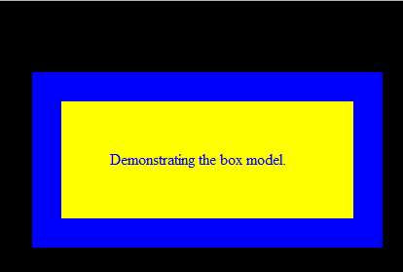

3. Using the URL below to help, make changes to the style to recreate the images that follow. Paste your style code for div.box for each one in the right column.

<http://www.w3schools.com/css/css_border.asp>

|  |  |
| --- | --- |
|  |  |
|  |  |

4. Replace the index.html code with:

<img class="box2" src="huish.jpg" >

You will need to download huish.jpg from Moodle to the same folder as index.html.

5. Replace the embedded style entry with:

img.box2

{

width:25%; height: 25%;

padding: 1%;

border: 50px solid red;

margin: 20px;

}

When you load the page you should see:

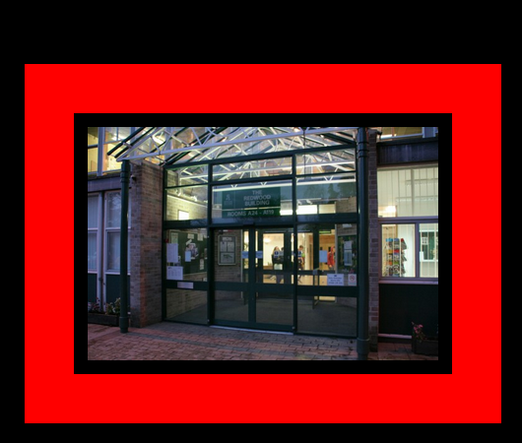

6. Make changes to the style to recreate the images that follow. Paste your style code for div.box2 for each one in the right column.

|  |  |
| --- | --- |
|  | img.box2  {  width:33%; height: 25%;  padding: 8%;  border: 10px solid red;  margin: 20px;  } |
|  | img.box2  {  width:33%; height: 25%;  padding:10%;  padding-right: 1%;  padding-left: 1%;  border: 10px solid red;  margin: 20px;  } |